EXP 1-2 Same or Different Report P2
Zeng Xinquan 2020304140 Yang Yu 2020304157 Sun Wenshao 2020304137
Zhang Chengyu 2020304104 Liu Zhening 2020304085 Li Yuntong 2020304106
Section 1: Mistakes identification and correction
The experimental mistake is generally caused by the wrong operation of the experimental process and data processing process, which should and can be corrected. Experimental error is the difference between the measured value and the real value, which is inevitable and unavoidable in the measurement process. To well analyze the experimental data, mistakes should be corrected.
● Mistakes:
Type 1: Beyond the elastic deformation interval. ----------------- Relevant groups: M2, M6.
Decision: Delete the last row of data in M2 and M6.
The last set of data of M2 and M6 has exceeded the elastic deformation interval, and the accuracy of the calculated modulus is affected. Therefore, the data beyond the elastic deformation interval should be deleted to ensure the calculation of the modulus.

Type 2: The abnormal stress and strain. -------------------- Relevant groups: M35, P12, PB.
Decision: Delete abnormal data in M35 and P12, and change the strain to 0 in PB.
M35, the second group of data, the stress is small but the strain is large, the data is abnormal, delete. P12, the second row of data, the stress is relatively large but no strain is reported, this row is deleted. For PB, after applied stress, a negative strain is obtained. Change the strain to 0.

Type 3: The processing problem of experimental data.------------------ Relevant group: P8.
Decision: Add up the weight and calculate the result again.
The experiment is to add continuous extra weight, record continuous weight, and finally distance. The stress and modulus calculated without cumulative weight are wrong. Weights need to be added up and recalculate the modulus.

Type 4: Typing mistake. ------------------------------------------------------ Relevant groups: P2.
Decision: Correct the wrong number (25mm to 2.5mm).
The thickness of the sample reported by P2 is 25mm, but it should be lacking a dot.

Section 2: Representability determining parameters
● Parameter 1: R²
The coefficient of determination (R²) is used to judge the fitting degree of the regression equation ^{[1]}. For the data provided, most results provided by polymer and material have R² near 1, meaning the regression equation fits the data well. However, for P8 and M11, R² is particularly low due to a mistake. After correcting the mistakes, the R² value became a satisfying value. Besides, the R² of the M38 Group is lower than 0.9 due to the error.
● Parameter 2: Standard deviation (SD) and Standard Error (SE) of the experiment result.
SD reflects how discrete a data set is ^{[2]}. The standard error of the mean indicates the degree to which the population means differs from the sample mean^{[2]}. In this experiment, the stand error shows how well the modulus is presented by the experiment result and helps to determine the significant figures. And stand deviation of each sample is used for further testing.

Section 3: Error identification & Data modification
● Error analysis
The several errors that exist are listed as follows:
Written error. The significant value of the result of measurement for each experiment is different, some groups keep the accuracy to 0.1 gram while others are not.
Measurement error. This error may occur in the case of inappropriate experimental operation or insufficient accuracy of experimental instruments. P13, P37, and M30 failed to record the change of strain while the stress is increased. This may be due to the insufficient accuracy of the instrument or uncareful reading.
Recording error. Some data haven’t been recorded in the correct form compared with other groups. P8 hasn’t accumulated the weight applied. And a row of data is missing in P22 and P24.
● Unit analysis
The unit of the calculation in the original table is Pa. It can’t well represent the tested polymer. To study how many figures in the modulus obtained are capable to show the property of the polymer tested, the SE of each experiment is calculated and the confidence interval is determined by CI=1.96*SE for 95% confidence. Since the CI is calculated to be in kPa, using kPa as the unit can eliminate all zeros and keep all significant figures. The modified data can better represent the population and is easier for further calculation. The comparison between modified and unmodified data is shown below.
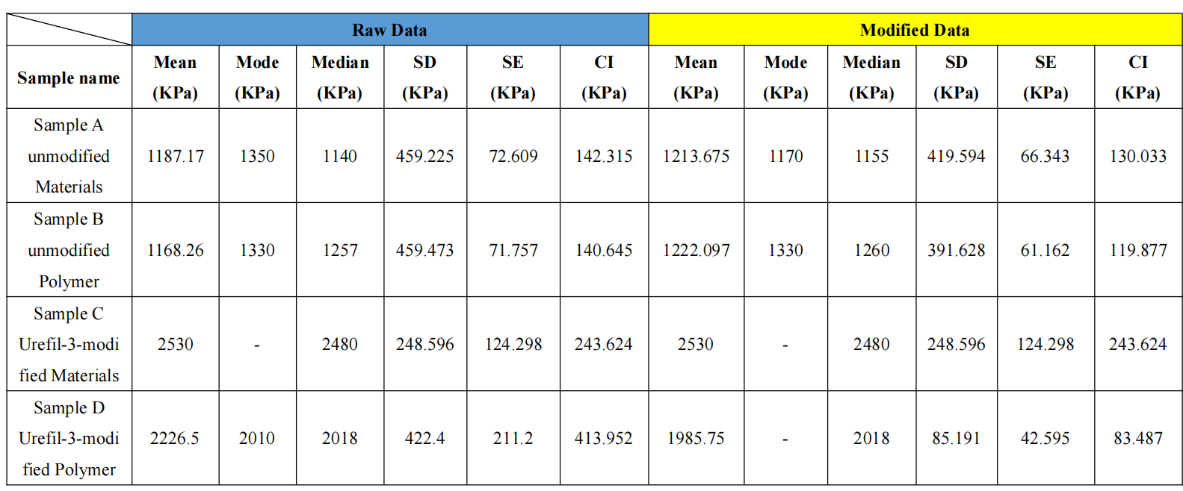

Table 1. The data before and after modification

Section 4: The normal distribution investigation
● Normality Test
To determine if the data samples follow a normal distribution, a normality test is performed. One common test is the Shapiro-Wilk test ^{[3]}. The null hypothesis for the test is that the data follows a normal distribution. If the p-value of the test is less than 0.05, we reject the null hypothesis and conclude that the data does not follow a normal distribution.
By using statistical software or a spreadsheet program like Origin, the Shapiro-Wilk test is performed on each sample, the results of the normality test have been shown below:
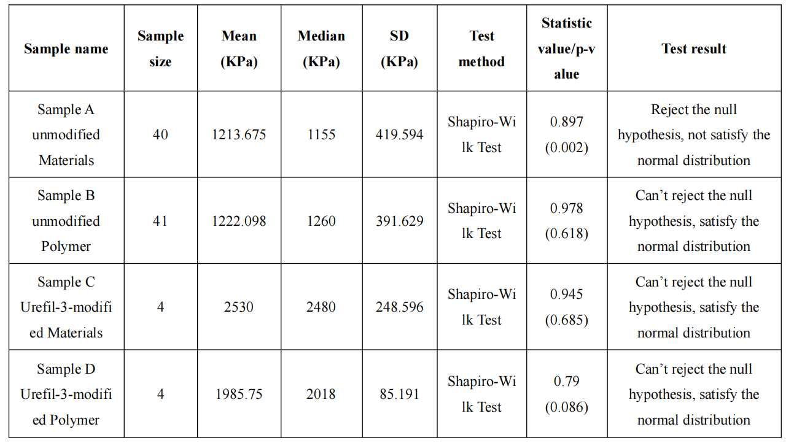

Table. 2 Normality test results
Based on the Shapiro-Wilk test, at the significance level of 0.05, it can be concluded that the data from Sample A-unmodified Material and Sample D-Urefil-3-modified Polymer does not follow a normal distribution, while the data from Sample B-unmodified Polymer, Sample C-Urefil-3-modified Material can be assumed to follow a normal distribution.
● Histogram Graph
To determine whether the data follow a normal distribution, a histogram also can be created and visually inspect the distribution of the data. For the histogram (a) of the unmodified material in figure1, there still exists a drift of mean value towards the left side in the normal distribution. In the histogram (b) for unmodified Polymer, the data are roughly normally distributed, with a bell-shaped curve in the histogram which is supported by the fact that the mean, median, and mode are all relatively close in value.
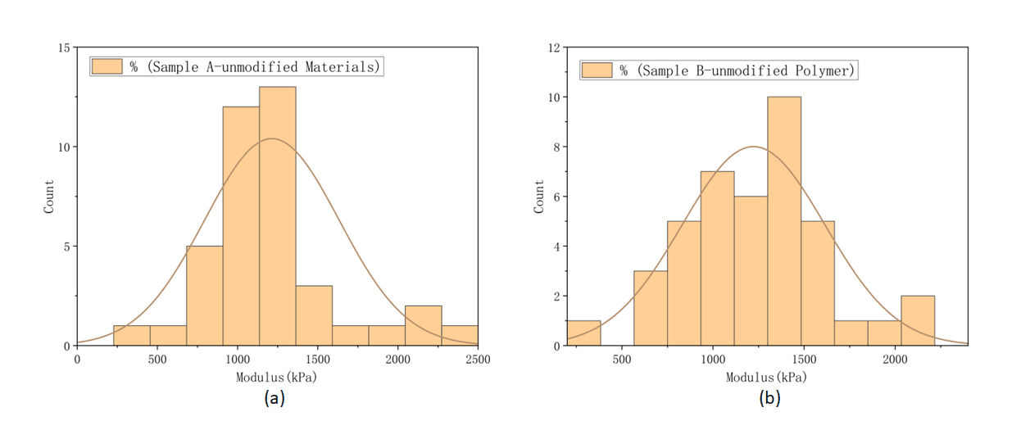
Figure 1. The histogram and normal distribution of (a) unmodified material sample and (b) unmodified polymer sample
Section 5: Comparability study of unmodified sample from the material group and polymer group
● Method 1: T-test
After correcting the mistakes, the sample size of both groups is larger than 30, thus the central limit theory holds true for both samples and the t-test is available. The two-tailed two-sample t-test (equal variances) is applied. The formula shown below is applied to obtain the t-value:
$$\begin{aligned}t=\frac{{\overline{X}}_{1}−{\overline{X}}_{2}}{\sqrt{\frac{{S_{1}}^{2}}{n_{1}}+\frac{{S_{2}}^{2}}{n_{2}}}}\#\left(1\right)\end{aligned}$$
As shown in table 3, the t value is calculated to be 0.093. The degree of freedom is calculated by the formula (2):
$$\begin{aligned}v=n_{1}+n_{2}−2=79\#\left(2\right)\end{aligned}$$
 | Mean ($X$) | SD (S) | Size (n) | T value
Material | 1213.675 | 419.5943943 | 40 | 0.093075749
Polymer | 1222.097561 | 394.0507289 | 41
Table 3. the result of the t-test between the material group (unmodified) and polymer group (unmodified)
By looking up the table, the critical t value is 1.990^{[4]}. Since the t value obtained is lower than the critical t value, the null hypothesis (H₀) cannot be rejected. It can be said that these two samples are from the same population and they are comparable.
● Method 2: Graphic
As shown in figure 3, the mean value of both two samples is relatively near each other. Due to the similar shape of the two graphs, it can be predicted that the two samples are from the same population. thus they’re comparable.
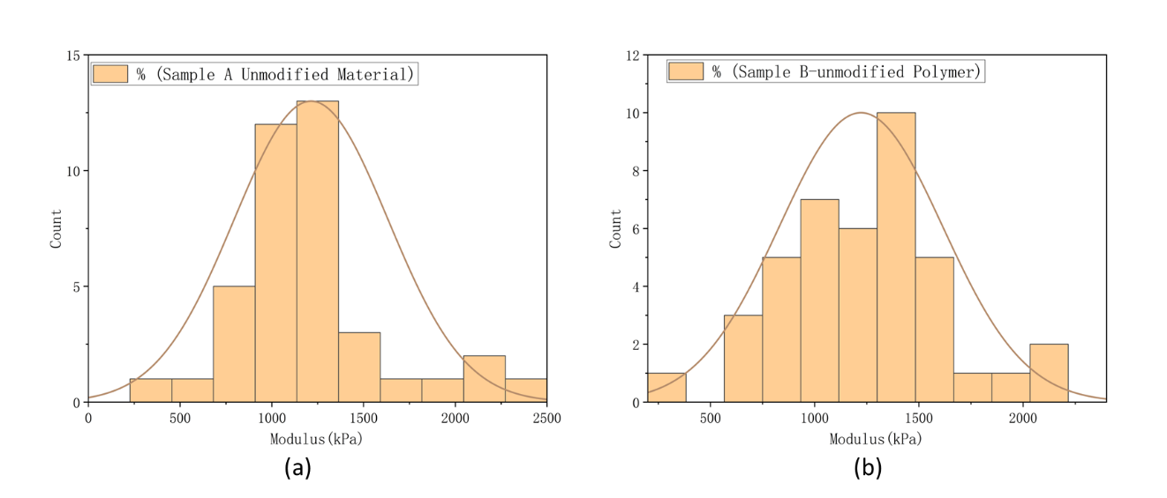
Figure 3. The histogram and normal distribution (plotted according to their mean value and stand error) of (a) unmodified material group and (b) unmodified polymer group

Section 6: Comparability study of the modified sample of material group and polymer group
● Method 1: T-test
Since the size of the modified material sample and polymer sample are both 4, it is too small to apply the z-test. According to the result of the normality test, both two samples satisfy the normal distribution, which makes the t-test available, some detailed results of the t-test have been shown below in table 4:

 | Mean ($X$) | SD (S) | Size (n) | T value
Material | 1985.75 | 85.19145106 | 4 | 4.142120656
Polymer | 2530 | 248.5960579 | 4
Table 4. the result of the t-test between the material group (modified) and polymer group (modified)
The degree of freedom is calculated to be 6. By looking up the table, the critical of the two-tailed test should be 2.447^{[4]}. The t-value calculated is 4.1421, which is larger than the critical t value, meaning that the null hypothesis (H₀) is rejected. These two samples are not from the same population, thus they’re incomparable.
● Method 2: Graphic
As shown in figure 4, the distribution of the two samples is different, thus they’re predicted to be incomparable.
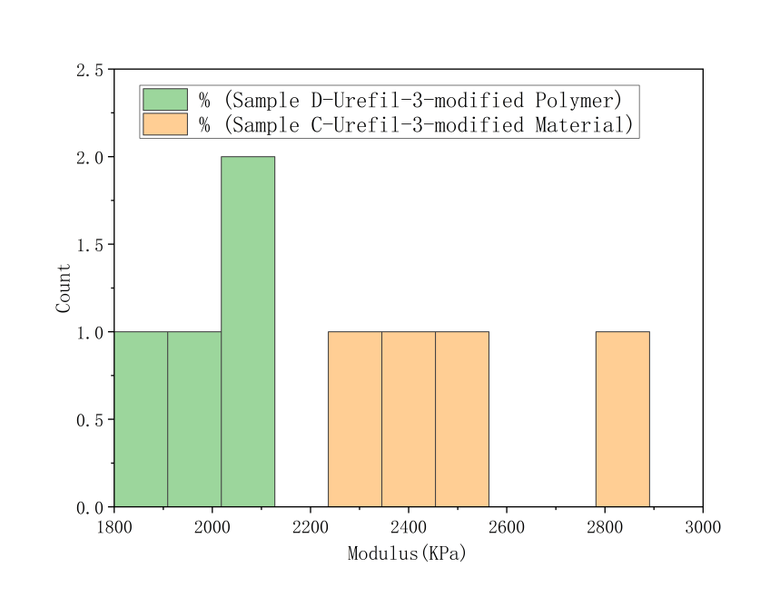
Figure 4. Comparison between modified samples

Section 7: Comparability study of the data of modified sample and unmodified sample
The modified samples are of small size. The unmodified samples are of large sample size (n>30) and can be regarded as normally distributed. The z-test, which can be used to check the difference between new data and a population can be applied.
● Method 1: z-test
The z-test is performed by using the formula (3), regarding the sample of the unmodified sample as a population and the modified sample as a set of new data. Since the modified sample from the material group is from a different population than the polymer group, the sample provided by the same group (polymer or material) is tested.
$$\begin{aligned}z=\frac{\overline{X}−μ}{S_{\overline{X}}}\#\left(3\right)\end{aligned}$$
The result is shown in table 5, compared with the critical value of z (z=1.96), both the results from the two groups are greatly larger than the critical value, meaning that the null hypothesis (H₀) is rejected. The modified samples is not from the same population with unmodified. And the modified one is incomparable to the unmodified one.
Group | SD of modified ($S_{\overline{X}}$) | The mean of modified ($\overline{X}$) | The mean of the unmodified group (μ) | Z-stand score (z)
Material | 248.5960579 | 2530 | 1213.675 | 5.295035694
polymer | 85.19145106 | 1985.75 | 1215.15 | 9.045508563
Table 5. The result of the z-test
● Method 2: Graphic
As shown in figure 5, there’s a great difference in the frequency distribution of the modified one and the unmodified one. The modified sample shows a higher modulus. From the figure, it is said that the modified one is from a different population than the unmodified one.
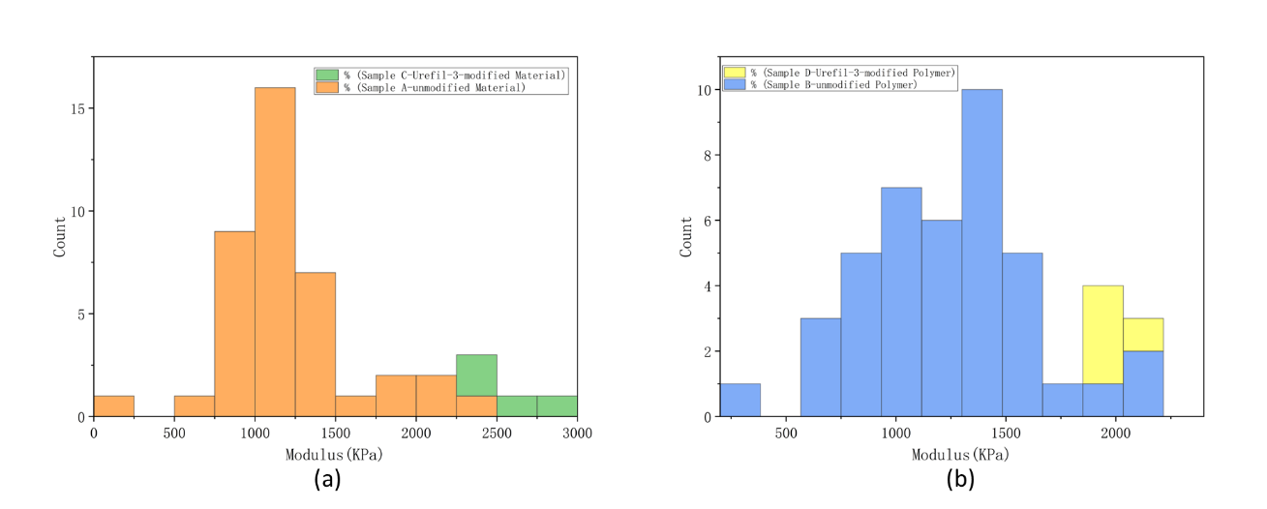
Figure 5. The comparison of histogram between modified and unmodified (a) material (b) polymer
Section 8: Reflection & Conclusion
During this data analysis task, the group start by thoroughly reviewing the data provided and identifying and correcting any potential issues and errors in the data, deciding which data points to remove or keep, and selecting appropriate statistical tests to compare different samples and verify the findings. To overcome these challenges, the group utilized a combination of the 7-step plan problem-solving skills, critical thinking, group management minutes plan (GMM) and effective group management strategies.

Reference:
[1] Turney, S. (2022, September 14). Coefficient of determination (R²): Calculation &amp; interpretation. Scribbr. Retrieved March 4, 2023, from https://www.scribbr.com/statistics/coefficient-of-determination/
[2] Bhandari, P. (2023, January 20). How to calculate standard deviation (guide): Calculator &amp; examples. Scribbr. Retrieved March 4, 2023, from https://www.scribbr.com/statistics/standard-deviation/
[3] “Shapiro-Wilk Test for Normality.” Encyclopedia of Measurement and Statistics, 2007, https://doi.org/10.4135/9781412952644.n404.
[4] 1.3.6.7.2. Critical Values of the Student's-T Distribution, from https://www.itl.nist.gov/div898/handbook/eda/section3/eda3672.htm.

